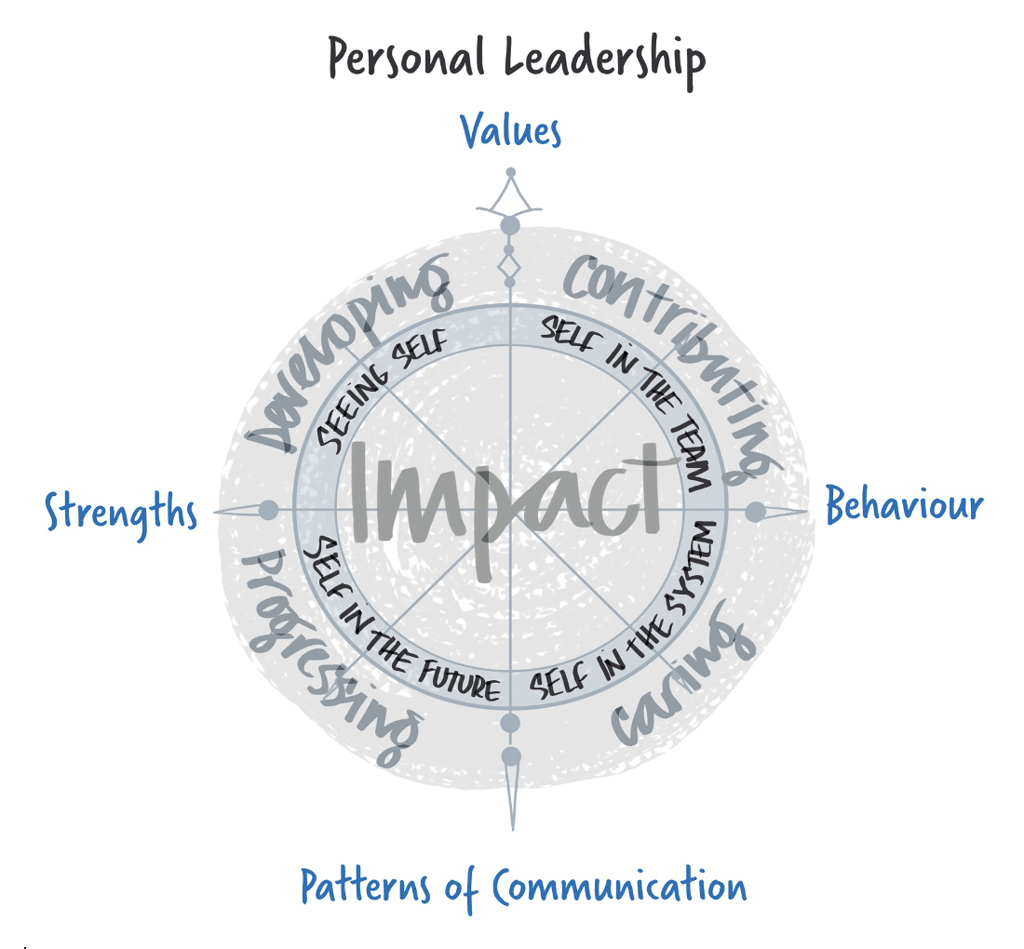

An Introduction to Transactional Analysis
Personal Styles Questionnaire

Transactional Analysis
It has always been my belief that if we each take responsibility for our impact and are honest enough to hear feedback then we can grow as people and as leaders. Transactional Analysis helps us to understand our responses to the communication and behaviours of others and to reflect on why we respond the way that we do. We can all get hooked by the communication and behaviours of others, especially if they reconnect with old tapes and patterns of behaviour. Leaders need to minimise the impact of the assumptions that they have about others, maximise listening and importantly maximise the impact of leadership communication.
In the early 1950s Dr Eric Berne developed a theory about personality development tied to communication, which he called 'transactional analysis' (TA). It is a very useful and fascinating framework for analysing the behaviour of both us and other people.
Complete the following questionnaire to learn more.

Personal Styles Questionnaire
The personal styles questionnaire begins to give you some insight into how values, beliefs, associated thinking and behaviour patterns have an impact on your communication preference. This is an overview only and it is important to realise that there are advantages and limitations to all the preferences.

Please approach this in your “work” frame of mind, especially how you are with colleagues, people you lead and your leader. For each statement allocate a score to show how much the behaviour is like the way you behave - go with your gut reaction and enjoy it!
Scoring Guidance
0 = Not true for me
1 = Sometimes true for me
2 = Generally true for me
3 = Nearly always true for me

1. I am firm in terms of behaviour that I consider acceptable/unacceptable.

2. I tend think things through thoroughly before making a contribution or taking action.

3. I believe that I should do as I am asked.

4. I behave sympathetically towards people with problems.

5. I really enjoy being with other people.

6. I enjoy taking care of people.

7. I enjoy solving problems in a systematic and logical way.

8. I am comfortable telling people what to do.

9. I let people know how I really feel without embarrassment.

10. I follow social norms in terms of expected behaviours.

11. I can sometimes be unpredictable.

12. I frequently find myself supporting new people or people new to a role.

13. I can stay calm in a crisis.

14. When I know I’m right I insist that others listen to me.

15. I ask a lot of questions.

16. I am passionate and excited about my work.

17. People seem to expect me to know the answer.

18. I pride myself that it is my role to take care of my people.

19. I am uncomfortable with upset or conflict.

20. I keep on thinking logically even under pressure.

21. My working style is systematic, methodical and organised.

22. It is important to me that I fit in.

23. I will often do things myself, rather than taking the time helping others to learn.

24. I can quote my previous experience when problems occur.

25. People tell me I’m creative and inventive.

26. I prefer to take control rather than follow someone else’s lead.

27. I can get over involved with people’s personal lives.

28. I’m over-emotional compared to others around me.

29. I expect my manager to set my terms of reference.

30. I take all points of view into account when making a decision.

31. I encourage people to test their own capabilities.

32. People complain I’m bossy.

33. I spend time enjoying myself.

34. I will go out of my way to look for what’s good in people.

35. I’m noted for my even temper and balanced comments.

36. I need people to understand how I am feeling to gain reassurance.

37. I have taken on the work of others.

38. I often over analyse and get absorbed in detail.

39. People do as I tell them.

40. I have agreed to and followed through on things that I didn’t agree with.

Scoring the Questionnaire
Transfer your scores to the table below against the appropriate question numbers.

Q | Score | Q | Score | Q | Score | Q | Score | Q | Score
1 |  | 4 |  | 2 |  | 3 |  | 5
8 |  | 6 |  | 7 |  | 10 |  | 9
14 |  | 12 |  | 13 |  | 11 |  | 15
17 |  | 18 |  | 20 |  | 19 |  | 16
24 |  | 23 |  | 21 |  | 22 |  | 25
26 |  | 27 |  | 30 |  | 29 |  | 28
32 |  | 31 |  | 35 |  | 34 |  | 33
39 |  | 37 |  | 38 |  | 40 |  | 36
TOTALS
 | Controlling Parent  CP |  | Nurturing Parent  NP |  | Adult  A |  | Adapted Child  AC |  | Natural Child  NC

Transactional Analysis
Berne believed that we are always operating from one or other of the states - in the way we habitually think and behave in response to life's stimuli. There are three 'ego-states' in which we think and behave as the Parent (CP Controlling Parent, NP Nurturing Parent), the Adult (A) or the Child (AC Adapted Child and NC Natural Child). These states are developed over our life and the influences, footprints and experiences form our values and beliefs, our thinking, including our thinking about leadership and our associated leadership behaviour.
We all operate in all the states, but we may be in some more than others. There is nothing wrong with being in a particular state. However, we may find it more helpful in achieving our outcomes to be in a particular state at a particular time. Generally, the Nurturing Parent, Adult and Natural Child States are the most positive. These are more likely to deliver the impact, ‘I’m OK and You’re OK’. The Controlling Parent and Adapted Child are less positive and more likely to deliver the impact ‘I’m OK and You’re not OK’ or ‘I’m not OK and You’re OK’.
Illustrated below in the model THE OK CORRAL
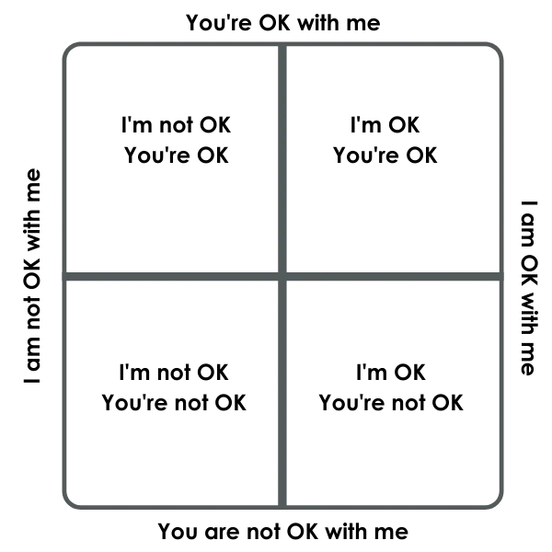

We are often asked about the perfect score. There is no such thing, only the patterns of communication that are effective, engaging those you lead to also taking ownership and responsibility for the future. The numbers represent the frequency with which you use each of the communication preferences. The bigger the gap between your top preference and the next represents the strength of the preference.

Parent State

The parent in TA is the set of recordings in a person's mind of imposed, unquestioned, external events perceived between birth and age 5 years. They are derived mostly from parents' (or ‘parental figures') speech and behaviour - admonitions, punishments, cuddles, encouragement. Berne says they are permanent and cannot be erased and at intervals throughout our lives they will be played back and influence our behaviour. It is sometimes described as 'Life as it is taught'.

When behaving in our parent state we can be judgemental, tradition-oriented, regulatory and conventional; alternatively, we may be supportive and protective. We think, feel and do as the 'parent figure' did - with views of right and wrong, good and bad and how we should behave, e.g. 'be strong', 'don't show your feelings', 'do as you're told' and 'feel responsible'. The parent state can be broken down into two aspects: controlling and nurturing parent.

The types of behaviour we display when we are operating in our parent state are:

As a Controlling Parent (CP) |  | As a Nurturing Parent (NP)
Behaviours  Sets limits/boundaries  Disciplines  Keeps traditions  Judges  Criticises  Makes rules | Words  should  always  never  ought  must | Behaviours  Gives advice  Coaches/develops  Protects  Comforts  Encourages  Nurtures | Words  let me  don't worry  it will all be fine  what do you need?  I can show you how to…
How do these behaviours and language relate to your personal values? |  | How do these behaviours and language relate to your personal values?
What does look like when it works? |  | What does look like when it works?
What does look like when it doesn’t work? |  | What does look like when it doesn’t work?

Positive Nurturing Parent - communicates the message "You're OK". When in this mode the person is caring and affirming.
Positive Controlling Parent - communicates the message "You're OK". This is the boundary setting mode, offering constructive criticism, whilst being caring but firm.
Negative Controlling Parent - communicates a "You're not OK" message and is punitive.
Negative Nurturing Parent - communicates a "You're not OK" message. When in this mode the person will often do things for others which they can do for themselves. When in this mode the person is engulfing and overprotective.
Child State
The child in TA consists of recordings of internal events (feelings) experienced in the first five years of life in response to external events. Berne says that, like parental recordings, those in the child are permanent and can easily be triggered by events in adult life so as to influence behaviour. When behaving in our child state we think, feel, do as we did when we were small - we are free/natural, creative, experimental, joyful, playful - we are obedient, rebellious, insecure, anxious, scared - adaptive so our needs are met. It is sometimes known as 'Life as it is felt'. The child state can be broken down into two aspects: natural/free and adapted child.

The types of behaviour can display when we are operating in our child state are:

As an Adapted Child (AC) |  | As a Natural Child (NC)
Behaviours  Obedient  Conditioned/conventional responses  Insecure  Anxious/scared  Sullen/rebellious | Words  No chance/I’ll try  Please/thank you  Sorry/I don’t care! I can’t do that/I won’t do that I’m only a… The organisation says... | Behaviours  Asks questions  Natural/free  Creative/Innovative  Experimental  Joyful  Lacks boundaries Selfish | Words  I’m wondering?  I’m curious?  I want to  mine  won't  scared  fantastic
How do these behaviours and language relate to your personal values? |  | How do these behaviours and language relate to your personal values?
What does look like when it works? |  | What does look like when it works?
What does look like when it doesn’t work? |  | What does look like when it doesn’t work?

Positive Adapted Child - communicates an "I'm OK" message. From this mode we learn the rules to help us live with others.
Positive Natural Child - communicates an "I'm OK" message. This is the creative, fun loving, curious and energetic mode.
Negative Adapted Child - expresses an "I'm not OK" message. When in this mode the person over-adapts to others and tends to experience such emotions as depression, unrealistic fear, and anxiety.
Negative Natural Child - in this mode the person runs wild with no restrictions or boundaries. In this mode they express a "You're not OK" message.

Adult
The third state, adult, is the last one to develop, beginning at around 10 months of age. It is formed from data acquired and computed through exploring, thinking out and testing ideas. We use the data stored in our parent and child states as information with a similar standing to that which we experience in the 'real' world - comparing and testing it to make it fit with other knowledge. We then store it in the adult, leaving the parent and child recordings unaltered. It is sometimes known as 'Life as it is tested'. When behaving in our adult state we operate in the 'here and now'; are rational and unemotional. We seek information, respect other people, and are assertive and considered in our communication.

As an Adult
Behaviours  Asking questions to gather data/information  Analytical  Rational and logical  Non-judgemental  Unemotional  Detached | Words  When/where/what  Who/why  Facts/alternatives  Results/reasons  Check it  Solutions
How do these behaviours and language relate to your personal values?
What does look like when it works?
What does look like when it doesn’t work?

Adult Accounting mode - communicates "We're OK" messages.

The Adult can assess reality in the here and now. It’s the Assertive place ‘off the emotional seesaw of the Parent/Child transactions. In Adult mode it is possible to choose which of the other effective modes to go into, dependent on the situation. When stable in this mode we are then able to respond appropriately, rather than flipping into archaic or historic ways of being, thinking and behaving which could be inappropriate and unhelpful.

However, the Adult can also be viewed as cold and detached and lacking emotional intelligence that is so critical in relationships and organisational life.

