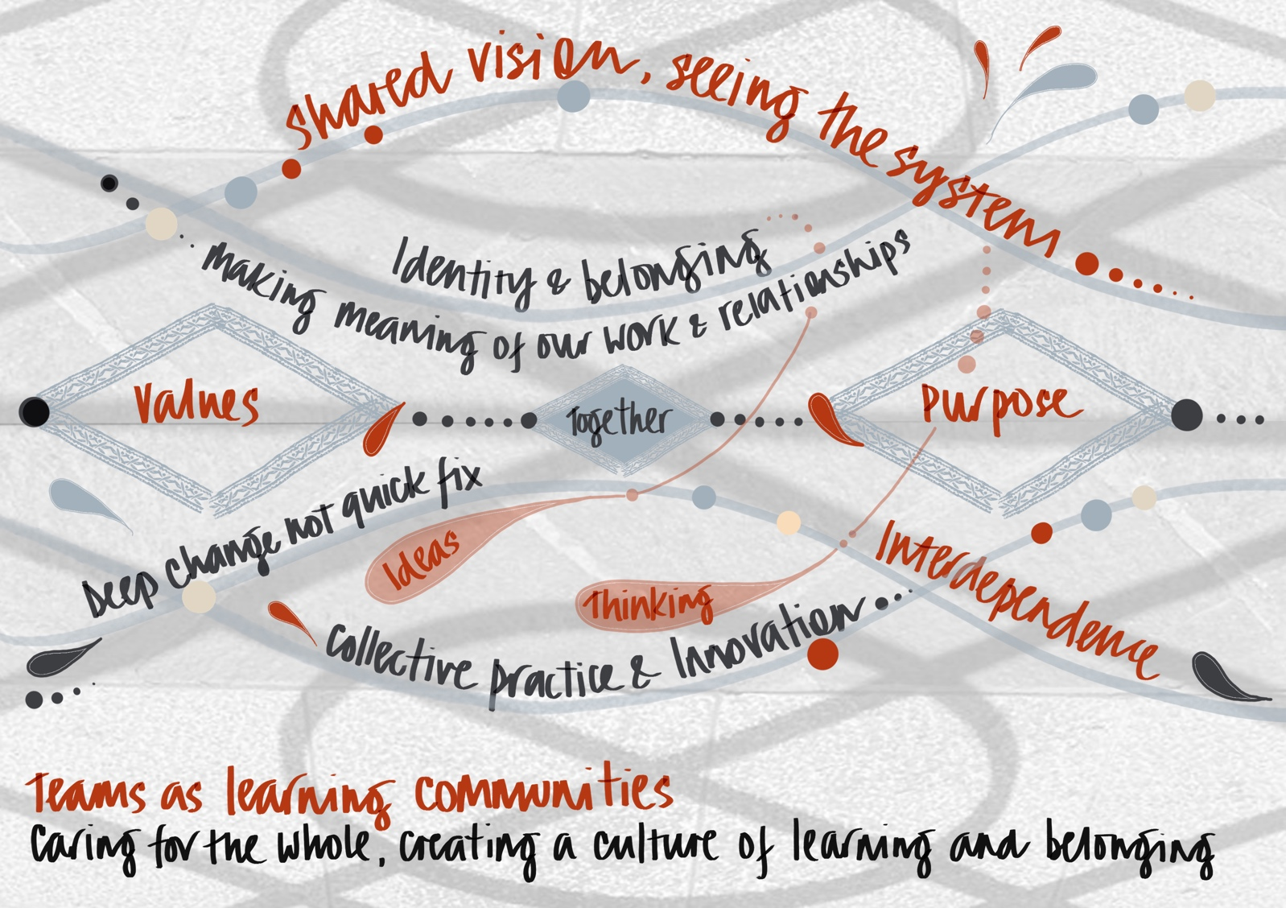

Teams as Communities of Practice

Team as Communities of Practice
Teams that function as Communities of Practice are connected, they are flexible, developing, focussed on learning, excellence and collective accountability. They are open and honest about why they are doing the work they are doing, how they will do it in a way that benefits patients and who is responsible for what by when. It is a focussed delivery environment balancing the demands of the organisation with the expectation that the patient is at the centre of a consistent and positive experience, whether directly or indirectly.
To maintain the health and well‐being of the team, the team takes care of itself and routinely takes time out to reflect on their relationships, results, ideas, challenges, successes and learning. This is a different type of get together than a meeting, this is a reflective listening space.

The following quiz creates an opportunity for you to think about this in terms of the principal team that you have a leadership relationship with. You may wish to have your team complete it as well as complete it yourself. This analysis will form part of your practical appreciative inquiry in the latter part of the programme.
Strongly Agree/Agree/Disagree/Strongly Disagree
Statement describing Team Behaviour | SA | A | D | SD
- There is common language among the team that creates strong communication
- There are positive rituals within the team that provide a sense of belonging
- There is a clear feeling of belonging within the team that provides a common bond
- The team has clear boundaries around behaviour

- The team has clear boundaries around ways of working

- Team members feel emotionally safe and can reveal how they really feel without fear
- Team members feel personally invested in

- There are friendships within the team that promote caring and unity
- The team acknowledges the needs of its members and looks to fulfil those
- Team members have an equality of influence

- The team is cohesive

- There are high levels of trust within the team

- Team members feel valued

- Team members value differences and use these to create new thinking
- The team has shared values

- The team is interdependent with other teams

- The team actively seeks out similarities, rather than differences

- There is excellent personal interaction within the team

- The team actively engages with unresolved tasks and issues

- The team members reward each other

- The team takes all credit or blame as a team

Totals

What are your top 4 ideas (as a result of the analysis) about how you can develop a more collaborative and appreciative team?

Appreciative Leadership and Teams as Communities of Practice - Initial Summary

Appreciative Leadership works because it treats people like people, and not like machines. Teams as Communities of Practice work because we are humans, we are social. We create our identities and our knowledge in relation to one another. We are curious. We like to tell stories and listen to stories. We pass on our values, beliefs, and wisdom in stories. We like to learn and use what we learn to achieve our best. And we delight in doing well in the eyes of those we care about and respect. Appreciative Leadership enables leaders to create natural communities of practice that are knowledge-rich, strength-based, adaptable learning organisations. Appreciative Leadership works because it liberates power. It unleashes both individual and organisational power. It brings out the best of people, encourages them to see and support the best of others, and generates unprecedented cooperation and innovation.

You will know if you are an appreciative leader if:

You build relationships enabling people to be known in a relationship, rather than in a role
You create an opportunity for people to be heard
You generate opportunities for people to dream, and to share their dreams
You create an environment in which people are able to choose how they contribute
You give people both discretion and support to act
You encourage and enable people

