Maslow's hierarchy of needs is a motivational theory in psychology comprising a five-tier model of human needs, often depicted as hierarchical levels within a pyramid.
From the bottom of the hierarchy upwards, the needs are physiological (food and clothing), safety (job security), love and belonging needs (friendship), esteem, and self-actualization.
Needs lower down in the hierarchy must be satisfied before individuals can attend to needs higher up.

1.Values: PSYSIOLOGICAL AND SAFETY
In the empty spaces below note any of your top 5 values from the online assessment that fit in these levels.
Next choose 0-3 from the list below.
Safety | Trust | Health | Competence
Compassion | Optimism | Curiosity | Security

2.Values: BELONGING(SOCIAL) /SELF ESTEEM
In the empty spaces below note any of your top 5 values from the online assessment that fit in these levels.
Next choose 0-3 from the list below.
Honesty | Justice | Equality | Efficiency
Connectivity | Generosity | Freedom | Tradition
Commitment | Love | Fun | Agility
Respect | Vision | Courage | Loyalty

3.Values: SELF ACTUALISATION
In the empty spaces below note any of your top 5 values from the online assessment that fit in these levels.
Next choose 0-3 from the list below.
Imagination | Creativity | Integrity | Service
Prosperity | Focus | Expression | Truth
Empowerment | Accountability | Learning | Self -Awareness

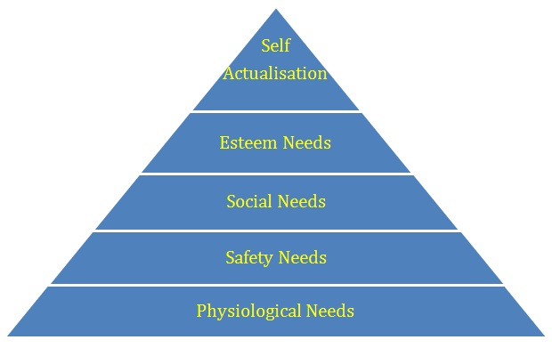
/Belonging
Questions:
What values from the second and third tables are important and non-negotiable regardless of what you’re doing?

How do you bring your values to life in your leadership role?

How do you recognise a clash of values with others?

